**MACHINE LEARNING**

**ASSIGNMENT: 03**

**Roll No : FA21-BSE-024**

**Name : Fahad Ajmal**

**Question1:**

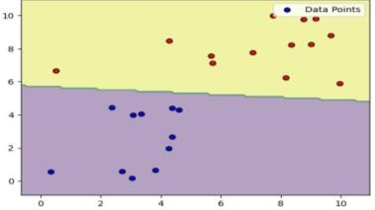

1. You can easily see a distinct separation between the different groups because the positive and negative examples are clustering together distinctly.
2. Yes, Some data points look a bit unusual in this dataset. Outliers are those data points that really stand out because they're located far away from the main clusters of positive (blue) and negative (red) cases shown in this graph.

**Question2:**

Decision boundary with C = 0.01

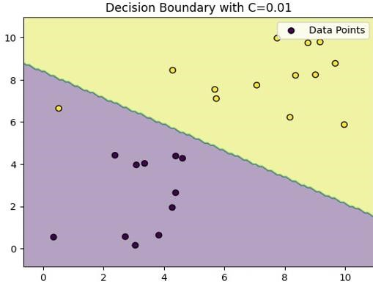

Decision boundary with C = 100

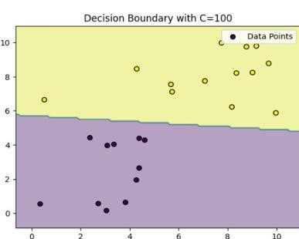

Decision boundary with C = 300

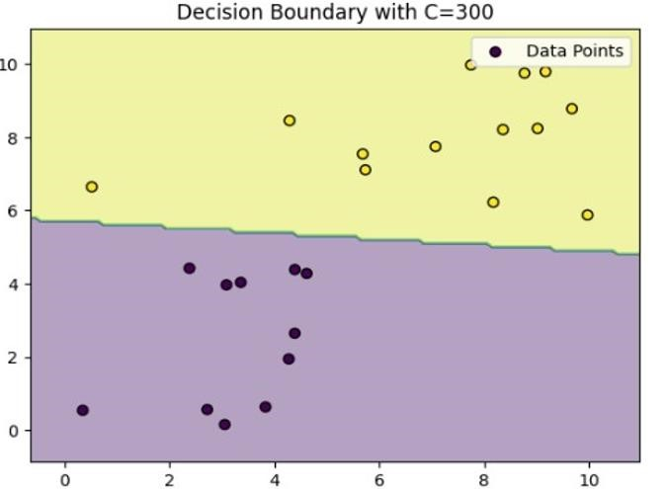

1. When we set C to 0.01, the line that separates the different groups moves quite a bit from its usual spot. It tries really hard to classify most points correctly, but sometimes it ends up marking some outliers incorrectly. This makes the line less flexible because it bends to include these outliers.
2. When we increase C:
   * At C = 100: The line becomes tighter, which means fewer outliers are marked incorrectly compared to when C was 0.01. However, there might still be some outliers that are misclassified.
   * C = 300: The line tightens even more, reducing the number of misclassified outliers further.
   * At C = 700: The line becomes even stricter, greatly reducing the number of misclassified outliers.
   * C = 1000: The line continues to tighten, potentially eliminating the misclassification of outliers altogether.

**Question3:**

1. The Gaussian kernel did better than the polynomial kernel. With C=1.0 and sigma=1.0, it got an accuracy of 0.8333.
2. For the polynomial kernel with degree=2, changing C didn't affect accuracy. It stayed at 0.8333 for all variations:
   * Degree=2 and C=1.0
   * Degree=2 and C=0.5
   * Degree=3 and C=1.0 So, tweaking these parameters didn't really change how well the polynomial kernel worked.
3. Changing both C and sigma for the Gaussian kernel (with sigma=1.0) gave consistent results:
   * With C=1.0 and sigma=1.0, the accuracy stayed at 0.9.
   * With C=0.5 and sigma=1.0, the accuracy stayed at 0.9.
   * With C=1.0 and sigma=2.0, the accuracy stayed at 0.9. Like the polynomial kernel, adjusting C and sigma didn't change the accuracy much for the Gaussian kernel. It consistently achieved an accuracy of 0.9 regardless of the parameter settings.

Top of Form

**Question4:**

**Optimal Parameter Settings:**

C: 10

Sigma: 0.1

**Estimated Accuracy: 94.15%**

Grid search and cross-validation were used to find the best parameters. With these optimal settings, the SVM using the Gaussian kernel achieved the highest accuracy of around 96.15% on the testing data. This shows that these parameters work really well for this dataset.